Rationale:
Diaspora Week encourages Israelis to explore various perspectives on the subject of global Jewry. This workshop seeks to foster a meaningful conversation between young Jewish individuals in Israel and their counterparts residing around the world, focusing on the theme of Jewish Peoplehood.
Section 1: Opening and Introduction
What does the term Jewish Peoplehood mean?
The concept of Jewish peoplehood underscores the notion that Jews globally possess a collective identity, history, and culture. It underscores the bond among Jewish individuals, emphasizing common values and a sense of community, irrespective of their geographical locations.
As a Jewish person, do you experience a sense of connection with fellow Jews residing on the opposite side of the globe?

Section 2: Breakaway room: Ice breaker and Jewish history timeline
Divide the group into separate breakaway rooms, ensuring a mix of both Israelis and Diaspora Jews in each room.
Icebreaker: Each particiant should introduce themselves and share what they think the most significant event in Jewish history for them. The group leader will write down these events , organizing them on a whiteboard into categories based on whether they occurred in Eretz Israel/Israel and or in other countries.
Activity: Below, you will find a list of important events in Jewish history. Arrange them in chronological order. Please be aware that the list is already oranized in chronological order to facilitate the session leader's access to answers. However, ensure that the order is randomized when presenting to participants.

Exodus from Egypt
Destruction of first temple and exile to Babylon
Edict of Cyrus- return from exile
Second Temple rebuilt
First Jewish Revolt against Rome
Destruction of Jerusalem and Second Temple
Bar Kochva Rebellion
Babylonian Talmud compiled
Spanish inquisition
Chmelnitzki massacres
French Jews granted full citizenship
Start of mass migrations of Eastern European Jews
Sir Nathaniel Meyer Rothchild became the first Jews in England's House of Lords
Alfred Dreyfus sentenced to life on "Devil's Island"
Theodor Herzl published "Altneuland"
The first Zionist Congress
Regina Jonas was ordained as first Liberal Rabbi in Germany
The Warsaw Ghetto Uprising
Jewish Brigade formed
Establishment of the State of Israel
Elie Wiesel wins Nobel Peace Prize

Section 2: Discussion regarding the status of Israel as a homeland for the global Jewish community:
The poem "New Pumbedita" written by Nathan Alterman in 1950, explores the theme of Jewish identity and disapora. Alterman, a prominent Israeli poet, playwright, and journalist, introduced the term "New Pumbedita" within this work to describe American Jews who chose to remain in the diaspora instead of making Aliyah. Pumbedita, an ancient Babylonic city, served as a historical reference where Jews thrived durin the Talmudic period, featuring a Yeshiva that symbolized the flourishing Jewish life in diaspora, sometimes even surpassing those in the land of Israel. Published in 1950, this poem critically examines the Jewish diaspora, particularly addressing American Jews who supported Zionism but did not contemplate relocating to Israel.
Let us read this poem together. (Attached)
Questions for disscussion:
What is Nathan Alterman describing in this poem? Alterman is describing the existence of two Jewish centers: Israel and the US (Cincinnatti as the center for Reform Judaism).
What is the difference between these two Jewish centers?
Is this still true today?
Has there always been more than one Jewish center?
Is there a need for two or more Jewish centers?

The Israeli Declaration of Independence, formally the Declaration of the Establishment of the State of Israel, was proclaimed on May 14, 1948 by David Ben-Gurion, the Executive Head of the World Zionist Organization, Chairman of the Jewish Agency for Palestine, and soon to be first Prime Minister of Israel.

Let us read together the opening paragrahs of the Israeli Declaration of Independence:
" ERETZ-ISRAEL [(Hebrew) - the Land of Israel] was the birthplace of the Jewish people. Here their spiritual, religious and political identity was shaped. Here they first attained to statehood, created cultural values of national and universal significance and gave to the world the eternal Book of Books.
After being forcibly exiled from their land, the people kept faith with it throughout their Dispersion and never ceased to pray and hope for their return to it and for the restoration in it of their political freedom.
Impelled by this historic and traditional attachment, Jews strove in every successive generation to re-establish themselves in their ancient homeland. In recent decades they returned in their masses. Pioneers, ma'pilim [(Hebrew) - immigrants coming to Eretz-Israel in defiance of restrictive legislation] and defenders, they made deserts bloom, revived the Hebrew language, built villages and towns, and created a thriving community controlling its own economy and culture, loving peace but knowing how to defend itself, bringing the blessings of progress to all the country's inhabitants, and aspiring towards independent nationhood.”

Questions for discussion:
How do you understand these paragraphs?
Considering our understanding of Jewish history, how do we perceive this? Are there aspects with which we resonate more or less in agreement?
How do you feel about the sentence:" the Land of Israel was the birthplace of the Jewish people. Here their spiritual, religious and political identity was shaped."? Was the Jewish people shaped in the land of Israel?

Due to the intricate and diverse history of the Jewish nation, two powerful themese have become interwoven in the Jewish consciousness: a deep attachment to Eretz Israel and the recognition of a vibrant Jewish life flourishing elsewhere, brimming with purpose and significance. Despite seeming contradictory, they themes are, in fact, mutually enriching.
Let examine the statistical date offered by the Jewish agency concerning the distribution of Jewish communities globally: https://www.jewishagency.org/jewish-population-5782/
Presently, 90% of the Jewish population resides primarily in two centers: the State of Israel and North America, leaving the remaining 10% disperesed across numerous other countries.
Considering this scenario, what do you perceive as the consenquences?
What does soldiarity of the Jewish nation mean?
In light of our belief in Jewish solidarity, what challenges emerge in the current landscape, and how can we effectively address them?
What does Jewish solidarity look like post-October 7th?

Conclusion:
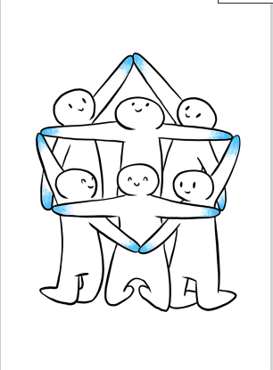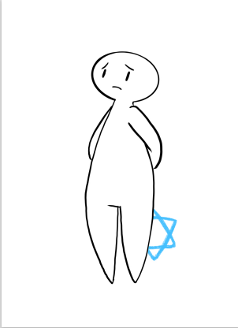




Displayed in front of you are four illustrations exploring the theme of Israel and Me. The intention behind these drawings is to foster an open and personal dialogue about your connection with the State of Israel. Take a moment to examine these drawings and select the one that resonates with your relationship to Israel.
Would anyone like to share their choice and provide insights into why they chose that particular drawing?
The events unfolding from October 7th until the present are challenging to digest and understand.
Questions for discussion:
What does October 7th signify in the Israeli context?
How do Jews worldwide perceive and experience the events of October 7th?

